Output #1 – This is the full set up of the SOHO

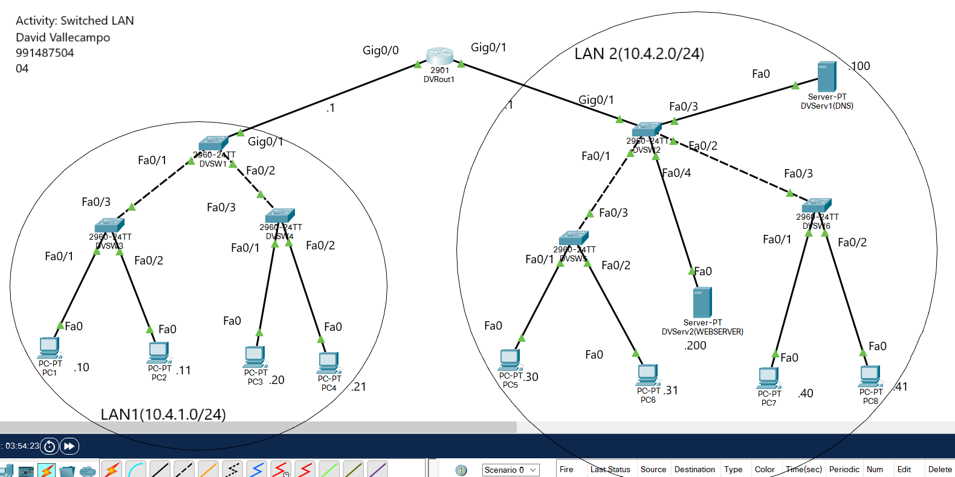

Output#2 - pinging LAN1 to LAN1

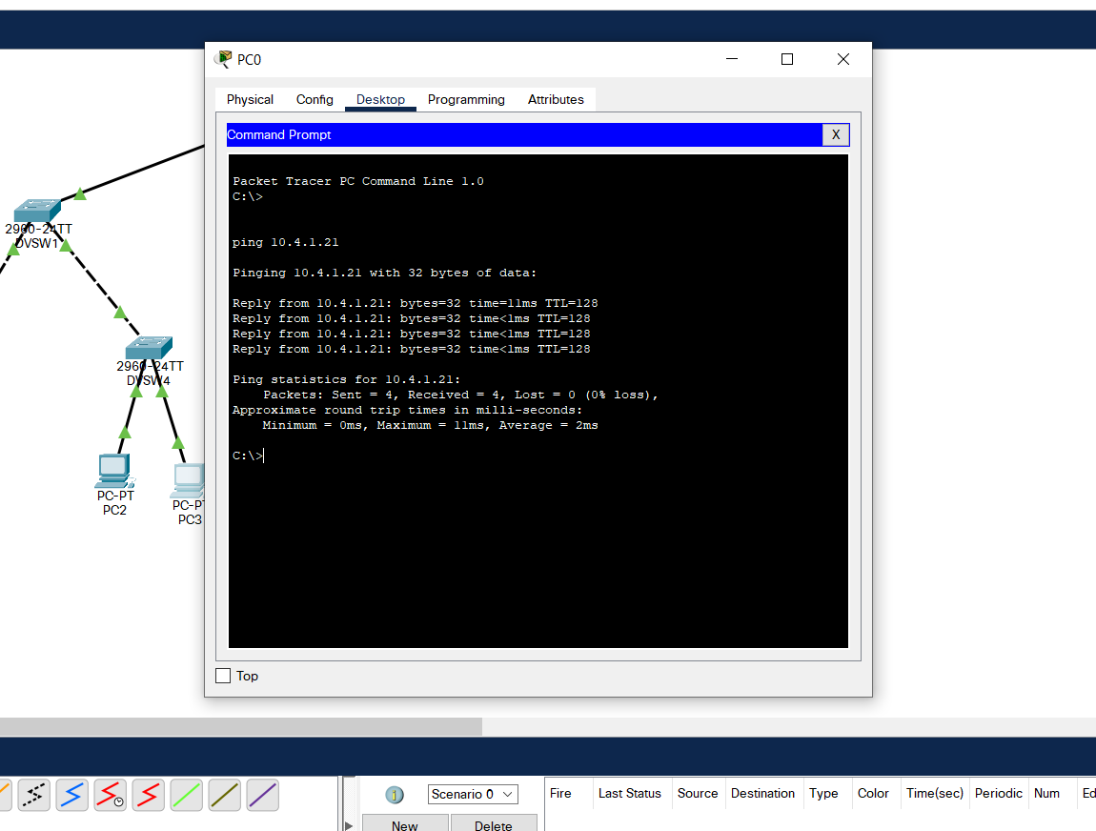

Output#3 - pinging LAN2 to LAN2

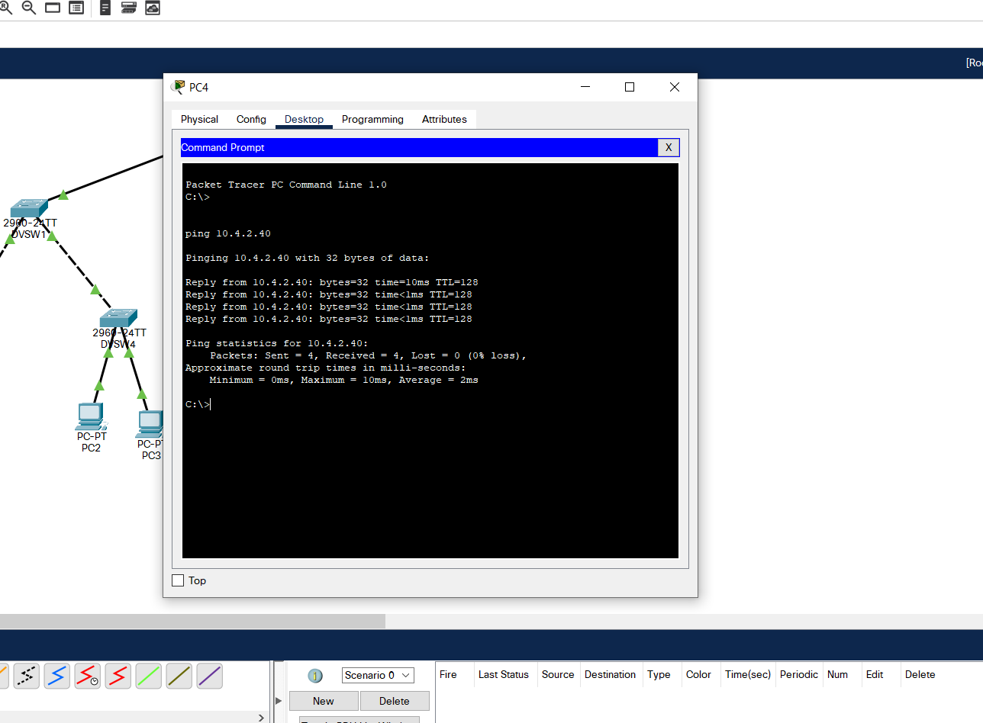

Output#4 – pinging between both LAN1 to LAN2 (Web Server)

